      - a. What is deep learning
Deep Learning is a subfield of machine learning concerned with algorithms inspired by the structure and function of the brain called artificial neural networks.

2. What is the need for validation data in deep learning?
The validation data set is used to measure how well our model is generalizing and for tuning the hyper parameters

b. what are the limitations of linear neurons
- The function’s derivative is a constant. That means there is constant gradient descent.
- Since the activation is linear, nesting in 2 or N number of hidden layers with the same function will have no real effect.

c. List any 4 applications of deep learning
- Self Driving Cars.
- News Aggregation and Fraud News Detection.
- Natural Language Processing.
- Virtual Assistants.
- Automatic hand writing recognition
- Automatic game playing
- Health care

d. Mention any 4 deep learning frameworks or tools
TensorFlow
Keras
PyTorch
Sonnet
DL4J

What are hyper parameters in neural networks
Parameters other than weights and biases.
Hyperparameters are the variables which determines the network structureand the variables which determine how the network is trained.

They are- no. of hidden units, no.of nodes in each layer, learning rate, no,of epochs etc

What are Hyper parameters in cnn

Stride, padding, no, of filters, mini batch size

What is overfitting?

- It refers to the phenomenon where a neural network models the training data very well but fails when it sees new data from the same problem domain.
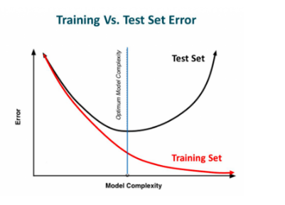

Over fitting is caused by noise in the training data that the neural network picks up during training and learns it as an underlying concept of the data. Avoiding over fitting can single-handedly improve our model’s performance

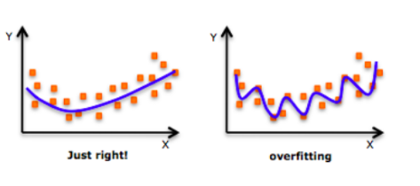
What is an epoch
An epoch is a single iteration over the entire training set. In other words, if we have a
training set of size d and we are doing mini-batch gradient descent with batch size b,
then an epoch would be equivalent to d/b model updates. At the end of each epoch, we
want to measure how well our model is generalizing.

e. List out the methods of preventing over fitting in deep learning
Regularization, Dropout

What is regularization.
Regularization modifies the objective function that we minimize by adding additional terms that penalize large weights. In other words, we change the objective function so that it becomes

Error + λ f (θ ) where λ is the regularization strength,

What is L2 regularization- (or) what is weight decay?
For every weight w in the neural network, we add 1/2λw² to the error function. During the gradient descent update, using the L2 regularization ultimately
means that every weight is decayed linearly to zero. Because of this phenomenon, L2 regularization is also commonly referred to as weight decay

what is L1 regularization-
we add the term λ|w| for every weight w in the neural network. neurons with L1 regularization
end up using only a small subset of their most important inputs and become quite
resistant to noise in the inputs.

What do you mean by Max norm constraints
Max norm constraints enforce an absolute upper bound on the magnitude of the incoming weight vector for every neuron and use projected gradient descent to enforce the constraint. One of the nice properties is that the parameter vector cannot grow out of control (even if the learning rates are too high) because the updates to the weights are always bounded.

What is Dropout

Dropout- While training, dropout is implemented by only keeping a neuron active with some probability p (a hyperparameter), or setting it to zero otherwise.

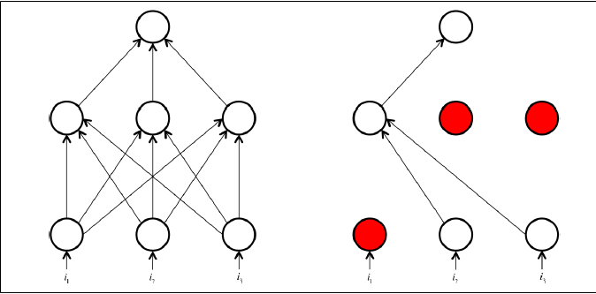

Here, a neuron’s output is set to 0 with probability 1 − p.
This means that if a neuron’s output prior to dropout was x, then after dropout, the expected output would be

E [output] = px + (1 – p). 0 = px.

What is Inverted dropout:

In inverted dropout, scaling occurs at training time instead of at test time. In inverted dropout, any neuron whose activation hasn’t been silenced has its output divided by p before the value is propagated to the next layer., 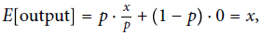

What is the need of Validation set in deep learning?

In machine learning , if our model is very complex we run the risk of overfitting.
Deep learning takes the approach of solving very complex problems with complex models and taking additional countermeasures to prevent overfitting.
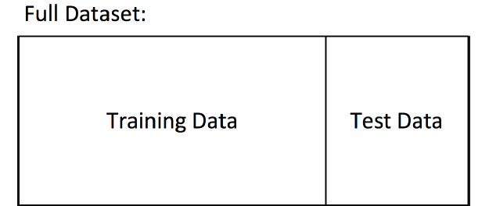

By dividing our data into train and test sets, the model measuring how well it generalizes on new data it has not yet seen. It’s quite likely that while we’re training our data, there’s a point in time where instead of learning useful features, we start overfitting to the training set.

To avoid that, we want to be able to stop the training process as soon as we start overfitting, to prevent poor generalization. To do this, we divide our training process into epochs..
At the end of each epoch, we want to measure how well our model is generalizing. To do this, we use an additional validation set.
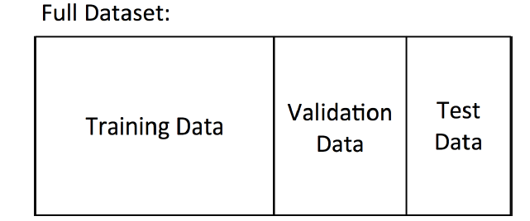
At the end of an epoch, the validation set will tell us how the model does on data it has yet to see. If the accuracy on the training set continues to increase while the accuracy on the validation set stays the same (or decreases), it’s a good sign that it’s time to stop training because we’re overfitting.

The validation set is also helpful as a proxy measure of accuracy during the process of hyperparameter optimization (hyperparameter -learning rate, minibatch size, etc.).

- What is cnn and its applications?

Convolutional Neural Network is an artificial deep learning neural network. It is used for computer vision/image recognition. This process includes the following operations:
- Image recognition and OCR
- Object detection for self-driving cars
- Face recognition on social media
- Image analysis in healthcare

- What is convolution?

A convolution operation is an element wise matrix multiplication operation. Where one of the matrices is the image, and the other is the filter or kernel that turns the image into something else. The output of this is the final convoluted image.

- What is the use of padding? (or) what is padding?
Every time we apply a convolutional operation, the size of the image shrinks
Pixels present in the corner of the image are used only a few number of times during convolution as compared to the central pixels. Hence, we do not focus too much on the corners since that can lead to information loss. To overcome these issues, we can pad the image with an additional border, i.e., we add one pixel all around the edges

- What is Striding
No of steps taken for convolution. Suppose we choose a stride of 2. So, while convoluting through the image, we will take two steps – both in the horizontal and vertical directions separately. Stride helps to reduce the size of the image, a particularly useful feature

- What is the use of pooling and types

Pooling layers are generally used to reduce the size of the inputs and hence speed up the computation.
Max pooling,min pooling, average pooling

- What is an autoencoder and its applications

An autoencoder is a type of artificial neural network used to learn efficient data codings in an unsupervised manner. The aim of an autoencoder is to learn a representation (encoding) for a set of data, typically for dimensionality reduction, by training the network to ignore signal “noise.
- Autoencoders are a specific type of feedforward neural networks where the input is the same as the output.
They compress the input into a lower-dimensional code and then reconstruct the output from this representation

- What is bottleneck?

The layer between the encoder and decoder, ie. the code is also known as Bottleneck

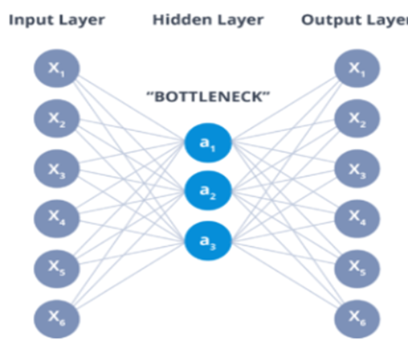
- Applications of Autoencoders
Dimensionality Reduction
Image Compression
Image Denoising
Feature Extraction
Image generation
Sequence to sequence prediction
Recommendation system

What are the Hyperparameters of Autoencoders
- Code size: It represents the number of nodes in the middle layer. Smaller size results in more compression.
- Number of layers: The autoencoder can consist of as many layers as we want.
- Number of nodes per layer: The number of nodes per layer decreases with each subsequent layer of the encoder, and increases back in the decoder. The decoder is symmetric to the encoder in terms of the layer structure.
- Loss function: We either use mean squared error or binary cross-entropy. If the input values are in the range [0, 1] then we typically use cross-entropy, otherwise, we use the mean squared error.

Comparision : PCA versus AutoEncoders
- PCA is a linear transformation of data while AE can be linear or non-linear depending on the choice of the activation function.
- PCA is pretty fast as there exist algorithms that can fast calculate it while AE trains through Gradient descent and is slower comparatively.
- PCA projects data into dimensions that are orthogonal to each other resulting in very low or close to zero correlation in the projected data. AE transformed data doesn't guarantee that because the way it’s trained is merely to minimize the reconstruction loss.
- PCA is a simple linear transformation on the input space to directions of maximum variation while AE is a more sophisticated and complex technique that can model relatively complex relationships and non-linearities.
- One rule of thumb could be the size of Data. Go with PCA for small datasets and AE for comparatively larger datasets.
- PCA hyperparameter is ‘k’ i.e. number of orthogonal dimensions to project data into while for AE it is the architecture of the neural network.
- AE with a single layer and linear activation has similar performance as PCA. AE with multiple layers and non-activation function termed as Deep Autoencoder is prone to overfitting and can be controlled by Regularisation and careful designing.

Auto encoder diagrams

PCa

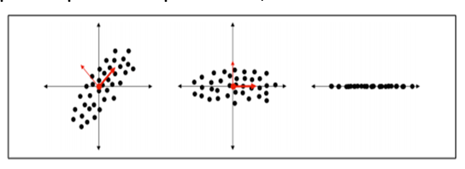

Dimensionality reduction with autoencoder
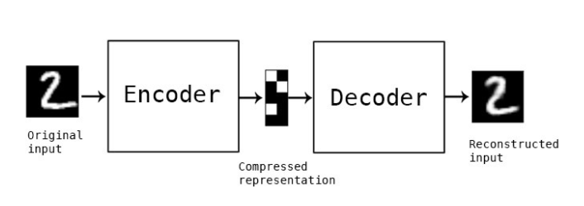
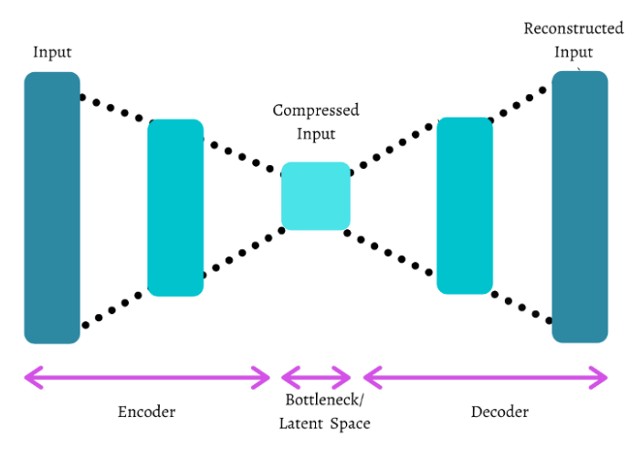

Diagram for Denoisy auto encoder

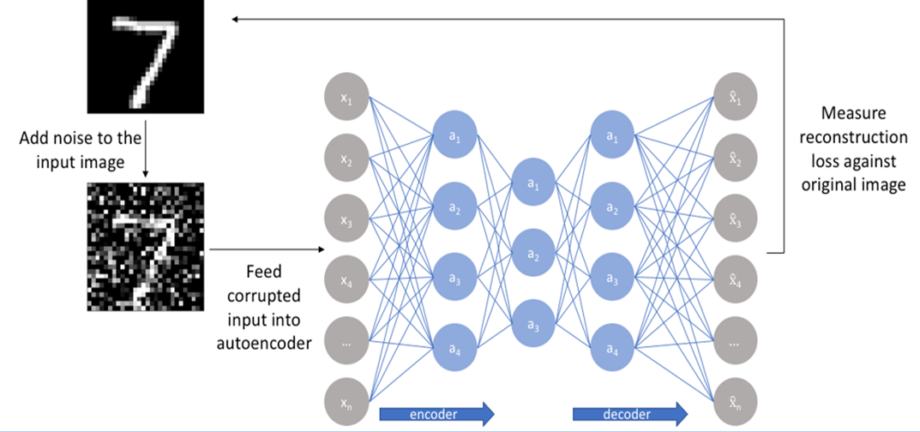

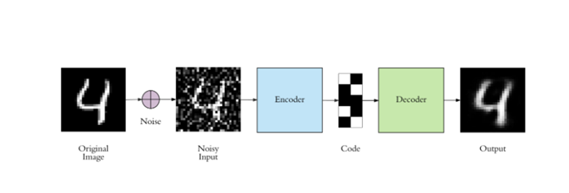

Diagrams for sparse autoencoders

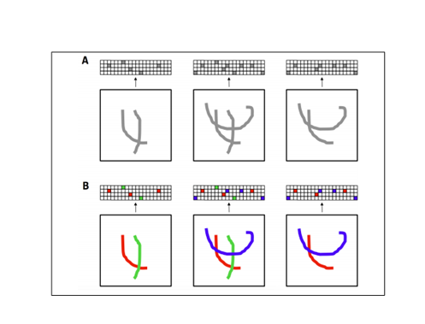
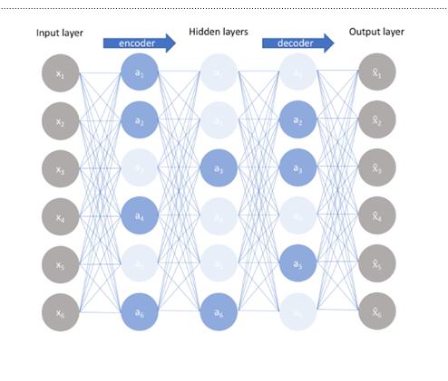
Diagram for auto encoder
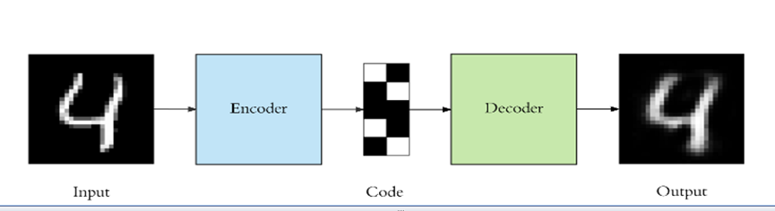
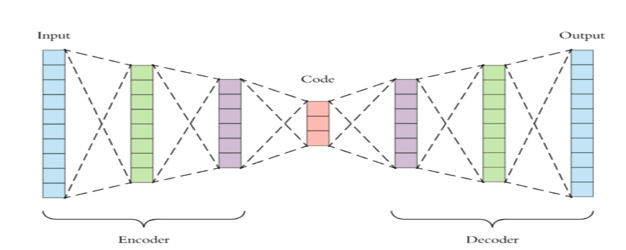

Applications of sequence modeling( RNN and LSTM)

  - Speech recognition (sequence to sequence):
  - Music generation (one to sequence):
Sentiment classification (sequence to one)
  - Machine translation from one language to another (sequence to sequence):

What is bPTT
- In RNN, States computed in the forward pass must be stored until they are reused during the backward pass,. The back-propagation algorithm applied to the unrolled graph is called back-propagation through time or BPTT

Stochastic and batch gradient descent

- batch gradient descent.
The idea behind batch gradient descent is that we use our entire dataset to compute the error surface and then follow the gradient to take the path of steepest descent.

- In Stochastic Gradient Descent (sometimes also referred to as iterative or on-line gradient descent) we update the weights after each training sample

Disadvantages of batch and stochastic
Batch- It is difficult for datasets that don't fit in memory. Batch gradient descent also doesn't allow us to update our model online, i.e. with new examples on-the-fly
Stochastic- SGD will keep overshooting, complicates convergence to the exact minimum and make gradient descent take a significant amount of time

Mini batch gradient descent

- Mini-batch gradient descent finally takes the best of both worlds and performs an update for every mini-batch of n training examples. Instead of summing over all the examples in the dataset, we sum over the examples in the current minibatch

What are the challenges of long term dependencies and how to overcome?
Vanishing/exploding gradients.
Recurrent neural network optimization algorithms must overcome the difficulty of vanishing and exploding gradient problem.
what is vanishing and exploding gradient descent?
- Recurrent networks, construct very deep computational graphs by repeatedly applying the same operation at each time step of a long temporal sequence.
- Repeated application of the same parameters gives rise to especially pronounced difficulties.
- During training, we compute the prediction error E^{(k)} and use the Back Propagation Through time algorithm to compute the gradient
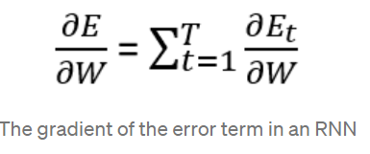
If we have learning task that includes large time steps, the derivative expression tends to vanish when time stpes are large, due to the derivative of the tanh activation function which is smaller than 1.
The product of derivatives can also explode if the weights are large enough to overpower the smaller tanh derivative, this is known as the exploding gradient problem.

What are Vanishing Gradients

Norm of the gradient, becomes so small due to increased model complexity with more hidden units, that it becomes zero after a certain point.

Exploding gradients
The Exploding gradients problem refers to a large increase in the norm of the gradient during training.

How to overcome vanishing/exploding gradients/

1. Gradient Clipping is a method where the error derivative is changed or clipped to a threshold during backward propagation through the network, and using the clipped gradients to update the weights

- Gradient Clipping is implemented in two variants:
- Clipping-by-value
- Clipping-by-norm
Gradient Clipping-by-value-We define a minimum clip value and a maximum clip value

Gradient Clipping-by-norm-we clip the gradients by multiplying the unit vector of the gradients with the threshold

2. Weight Regularization

Another approach, if exploding gradients are still occurring, is to check the size of network weights and apply a penalty to the networks loss function for large weight values.

This is called weight regularization and often an L1 (absolute weights) or an L2 (squared weights) penalty can be used

3. Leaky Units

One way to deal with long-term dependencies is to design a model that operates at multiple time scales, so that some parts of the model operate at fine-grained time scales and can handle small details, while other parts operate at coarse time scales and transfer information from the distant past to the present more efficiently.

- Various strategies for building both fine and coarse time scales are possible. These
include the addition of skip connections across time, “leaky units” that integrate signals with different time constants, and the removal of some of the connections used to model fine-grained time scales

Leaky units:

- Hidden units with linear self-connections can behave similarly to running averages. Such hidden units are called leaky units
- When we accumulate a running average μ(t) of some value v(t) by applying the
- update μ(t) ← αμ(t−1) + (1 − α)v(t) the α parameter is an example of a linear selfconnection from μ(t−1) to μ(t). When α is near one, the running average remembers
information about the past for a long time, and when α is near zero, information about the past is rapidly discarded

1.a. List the types of layers in CNN.
Input, convolution, pooling, fully connected, softmax (output)

b. What is the difference between deep and shallow network?
Shallow neural networks is a NN that usually have only one hidden layer where as a deep NN have several hidden layers

c. what is word embedding?
Word embedding is representing a word in the form of a vector or encoding a word

d. How to represent filters and feature maps as neurons in a convolution layer?
Layers of neurons in a feedforward neural net represent either the original image or a feature map. Filters repre‐ sent combinations of connections that get replicated across the entirety of the input. A neuron in the feature map is activated if the filter contributing to its activity detec ted an appropriate feature at the corresponding position in the previous layer.

e. Write the function of denoising autoencoder?
Denoising autoencoder generates embeddings that are resistant to noise.

f. What is sparsity in autoencoder?
A sparse autoencoder is simply an autoencoder whose training criterion involves a sparsity penalty to improve interpretability.

g. Define computational graph
A computational graph is an unfolding of a recursive or recurrent neural network that that has a repetitive structure

h. Write short notes on bidirectional RNNs
Bidirectional RNNs combine an RNN that moves forward through time beginning from the start of the sequence with another RNN that moves backward through time beginning from the end of the sequence.

i. What is overfitting in deep neural networks?
It refers to the phenomenon where a neural network models the training data very well but fails when it sees new data from the same problem domain

J. Write the difference between feed forward network and recurrent network.
Feedforward neural networks pass the data forward from input to output, while recurrent networks have a feedback loop where data can be fed back into the input at some point before it is fed forward again for further processing and final output.

What is attention mechanism

Attention Mechanism in deep neural networks is an attempt to mimic the human brain by selectively concentrating on a few relevant things, while ignoring others.

What is GAN?

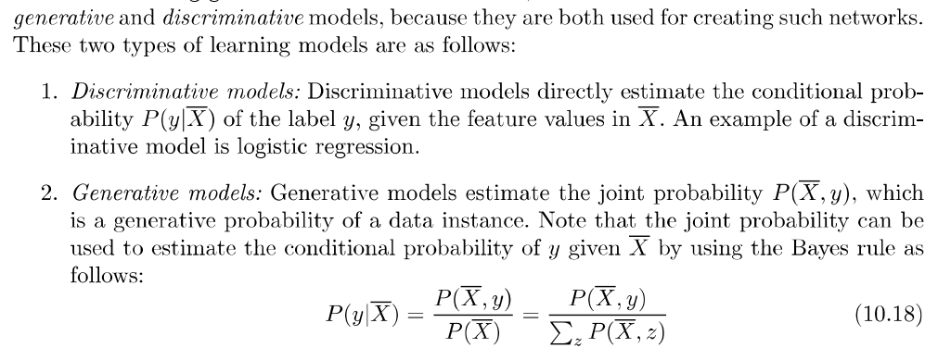

What is Conditional GAN (CGGAN)
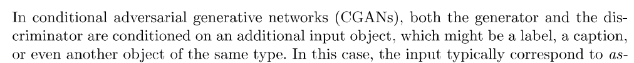

What is deconvolution (or) transposed convolution (or) fractionally strided convolutions?
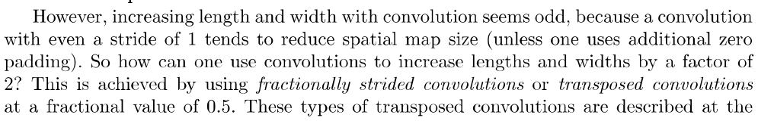
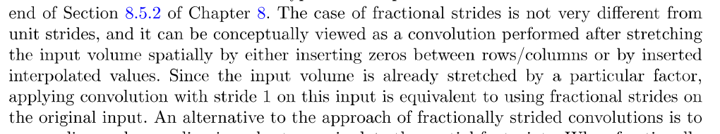

What is neural turing machine

A neural Turing machine (NTM) is a neural network architecture that can learn to perform complex tasks by reading and writing to an external memory.

What is one shot learning
The general principle of being able to learn from one or very few samples is known as one shot learning

What is competitive learning
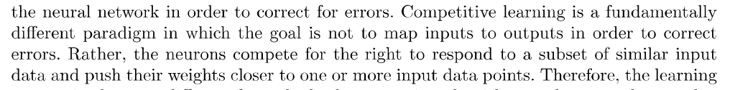

What is Kohenen Self organizing map
Self Organizing Map (or Kohonen Map or SOM) is a type of Artificial Neural Network which is also inspired by biological models of neural systems from the 1970s. It follows an unsupervised learning approach and trained its network through a competitive learning algorithm. SOM is used for clustering and mapping (or dimensionality reduction) techniques to map multidimensional data onto lower-dimensional which allows people to reduce complex problems for easy interpretation.

Applications of attention mechanism

Image captioning, object detection, Visual question answering, image segmentation

Explain Image Preprocessing techniques used in cnn
Natural images are messy, and as a result, there are a number of preprocessing operations

that we can utilize in order to make training slightly easier. The first techniquethat is
supported out of the box in TensorFlow is approximate per-image whitening.
The basic idea behind whitening is to zero-center every pixel in an image by subtracting
out the mean and normalizing to unit 1 variance. This helps us correct for potential
differences in dynamic range between images. In TensorFlow, we can achieve this
using:
tf.image.per_image_whitening(image)
We also can expand our dataset artificially by randomly cropping the image, flipping
the image, modifying saturation, modifying brightness, etc: Some exaples:
tf.random_crop(value, size, seed=None, name=None)
tf.image.random_flip_up_down(image, seed=None)
tf.image.random_flip_left_right(image, seed=None)
tf.image.transpose_image(image)
tf.image.random_brightness(image, max_delta, seed=None)
Expalinabout Batch Normalization
Training of feed-forward and convolutional neural networks can be accelerated using a technique
calledbatch normalization
In the process of training the weights of the network, theoutput distribution of the neurons in the
bottom layer begins to shift. The result ofthe changing distribution of outputs from the bottom
layer means that the top layernot only has to learn how to make the appropriate predictions, but it
also needs tosomehow modify itself to accommodate the shifts in incoming distribution. This
significantlyslows down training, and the magnitude of the problem compounds themore layers
we have in our networks.

Normalization of image inputs helps out the training process by making it morerobust to
variations. Batch normalization takes this a step further by normalizinginputs to every layer in
our neural network. Specifically, we modify the architectureof our network to include operations
that:
1. Grab the vector of logits incoming to a layer before they pass through the nonlinearity
2. Normalize each component of the vector of logits across all examples of the minibatch
by subtracting the mean and dividing by the standard deviation (we keep
track of the moments using an exponentially weighted moving average)
3. Given normalized inputs x̂, use an affine transform to restore representational
power with two vectors of (trainable) parameters: γx̂ + β

Without batch normalization, cracking the 90% accuracy threshold requires over80,000
minibatches. On the other hand, with batch normalization, crossing the samethreshold only
requires slightly over 14,000 minibatches.
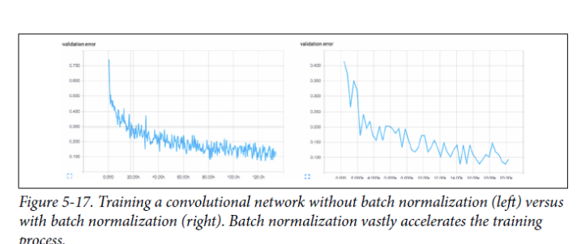

- Write any two differences between RNN and CNN?
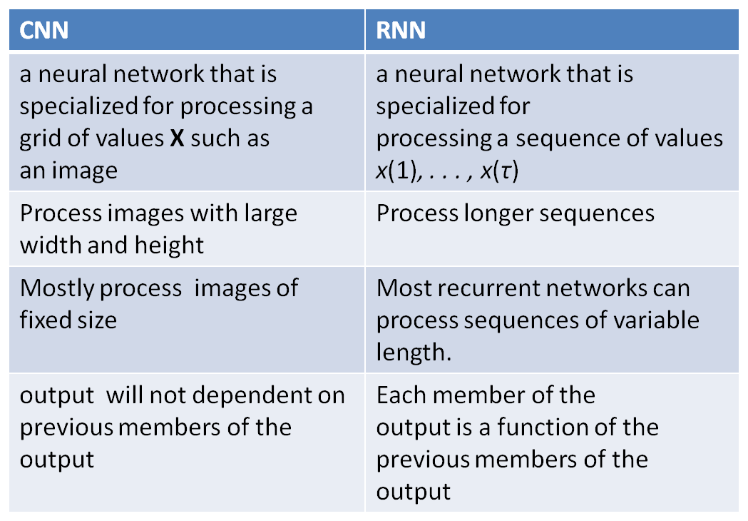

Applications of visual attention

Image captioning, google street view,
multimedia delivery, retargeting and quality assessment of image and video, medical imaging, and the field of stereoscopic 3D images applications.

